My School and Email



With an Introduction to ERGS ICT

Name:
Form:
Teacher:

Introductions
Welcome to the ICT Department at Enniskillen Royal Grammar School. In this subject, we will learn about all manner of things about computers. From how a computer stores data all the way to editing and creating computer graphics. We are a programming school, which means we will learn about how to write code – this way you will be able to program your own games, websites and even have the skills to start creating your own apps and programs!
In order to take you on this journey, however, we are going to need to start with the basics – primarily how to access the computers and your work, how to communicate with your teachers and also some of the fundamental programs you will need to be familiar with before we can take on the more complex stuff.
First of all, we need to learn about My School and Google Classroom, which is the basics you will be using in every subject throughout the school. Some of you may have already used these in primary school and might be able to help those who haven’t used them before, and that way we can start learning about what goes on inside of a computer.

Acceptable Use of Our Computers
It is very important that we all use the School Network for our education, as every subject taught in school makes use of Google Classroom. Even our school clubs and teams use them to keep updates and notifications at the tip of your fingertips. It’s important to know that because of this all users of the network are expected to act responsibly and to show consideration to others. Using our school network/computers for non-educational purposes will bring about sanctions.
We have an acceptable use policy in place, which is to both keep you safe and also keep our network and data safe.
It goes without saying that you should never share your password with anyone, as you nor anyone else should logon to or use any account other than their own. This means you should logoff when leaving a workstation.
It is not acceptable to:
- download,
- store or
- install
software to school computers.
It is not acceptable to attempt to introduce a virus or malicious code to the network. You shouldn’t attempt to access, download, create, store or transmit material that is indecent or obscene and brings the name of the school into disrepute.
We do not allow the use of public chat facilities and social networks, and attempt to access these will be noted on your account.

Computer room rules
Take note of the top 10 rules of the Computer Room here:
1
2
3
4
5
6
7
8
9
10

Absence from Class
One major rule that the ICT Department has is with regards to absence from class.
If you are absent from class, for any reason, it is your responsibility to catch up before next lesson.
This includes:
- Checking if any homework is due (and needs to be completed)
- Catch up on any work/notes missed. If you do not understand what you have missed, see me before the next lesson.
- If there was a class test, you need to see me before next lesson to complete this or so I can arrange a time for you to do the test.
I will not accept ‘I wasn’t here last lesson’ as an excuse for not completing homework.
You can speak with your peers in class, or contact me directly via google classroom or email. I will show you how to access your school emails and google classroom in the coming lessons. For now, you can speak with your teacher if you have any difficulties accessing work or are absent from class.
If you know you will be absent from class, it would be a good idea to let your teacher know so you can complete the work early and have it done for the next lesson.


Pupil Baseline Survey
https://forms.gle/E3vio97kpBb1AwWm8
This baseline survey is not a test. It is simply to assist your teacher to review your level of access to ICT equipment at home and to foresee any issues you may have with access to IT programs we might use in class.
It is very important you complete this accurately, so don’t worry what other people put in as their answers. You should only focus on your responses and make them as full and as accurate as possible.
Please ensure you use your c2k email address to complete this form!
@c2ken.net
My c2k Email Address is:

What is a computer?

What is a Network?

Networks
There are lots of networks you have used before, including:
- The Internet
- Home WiFi
- Social Networks
- Gaming Networks

The Internet
The internet is a world wide network. It allows computers from all over the world to communicate with each other, such as sending email, online gaming and social networks.
Nobody is in charge of the internet, which means that anybody can put whatever they want onto it. This can cause problems as offensive material can appear on the internet. Fortunately, the police can track and identify everything that is posted as the Internet keeps track of all the computers connected to it.
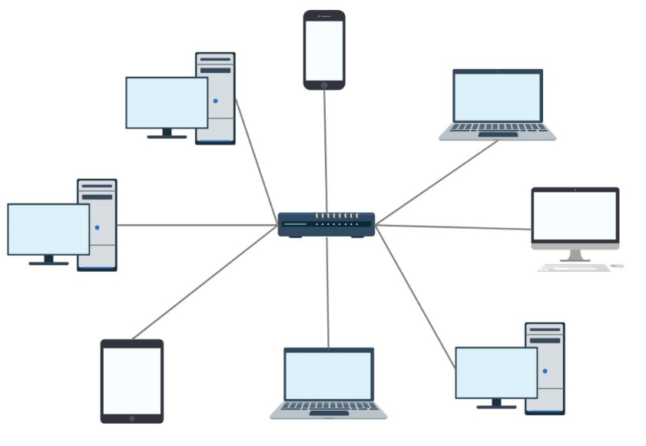
The School Network

All the computers on our school network are controlled by a main computer called a “Server”.
This allows people to save their files centrally and share things like printers.
The computer you are using is called a “Work Station”.
In some networks, there is a switch or ‘hub’ in the centre of the network. But for now, we will always label the centre node as a server.
Work Station
Server (or switch)

Setting Strong Passwords
When using networks, it is really important we keep our access secure. We can do this by using a username and password. However, we can’t just use any old password – that wouldn’t be very secure. Instead, we need to ensure our passwords conform to a strong password policy.
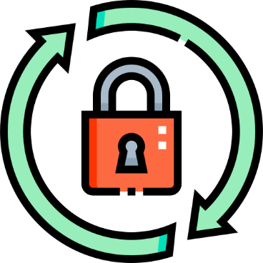
For example, a strong password policy could be:
- At least 8 characters –
- At least one capital letter
- Use some numbers
- Use symbols (like $, %, !, etc)
- Difficult to guess – it shouldn’t just be one or two words

Listening Quiz
This is a quick quiz to see if you have been listening! Write out the answer to the questions below.
- What is a network?
[1]

- What is a server?
[1]

- What is the internet?
[1]

- Why does everyone need a unique Log In for the school network?
[1]

- What should be in a strong password?
[5]

- What activities are not acceptable on the school network?
[7]

- What could happen if I break the rules?
[1]
/17


File Management
It is really important to keep an organised folder in every subject for multiple reasons. It’s also important you keep an organised folder structure on the computer for the same reasons.
- Much easier to locate files - always know where to find what you need, and you will never waste time wondering where to save anything. If needed, you can easily direct someone/teacher to access a file for you.
- It’s easier to keep backups.
- No files need to be saved in several places, so there’s no need to save files multiple times as you can’t find the first one you saved!
- It’s more efficient in terms of storage, so you don’t need lots of storage capacity storing the same files wasting space.
- If time is a limiting factor, you can find the file quickly.


Email and Search Engines
Email stands for ‘electronic mail’. It is a message sent from one computer to another over the internet.
In order to use email, you need:
- An email account (Gmail/Yahoo/AOL/Hotmail etc)
- Email software (Outlook/Webmail/Thunderbird etc)
- Internet Access (BT/Virgin/TalkTalk/Plusnet etc)
Just like sending a letter in real life, sending an email follows the same rules. It is a formal way to message someone, so should be professional. You should also consider your netiquette when sending emails. Netiquette is a term used to show how you should behave when sending emails and using the internet.
It includes:
- Being polite
- Never forget the subject line – who ever receives your email needs to know what it is about
- Do not type all in capitals as this looks like shouting
- Don’t use “text language” – not even when sending to friends.
- Let people know if you are joking by using a smiley face :) Emoticons are acceptable for less formal emails, such as emails sent to friends. However, they should be discouraged when sending a formal email (such as to a teacher or boss).

There are two people involved when sending emails:
- The sender – the person who sends the email
- The recipient – the person who receives the email.
When a message is sent, it appears in the recipient’s inbox, and the sender’s outbox. The recipient will need to open the email to read it.

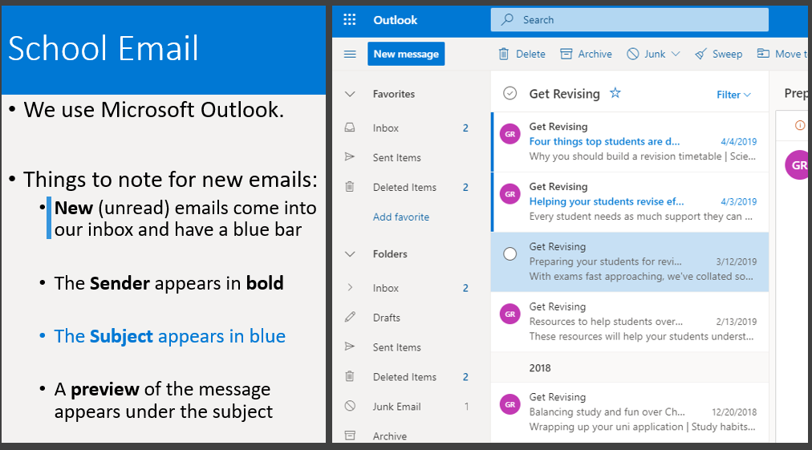

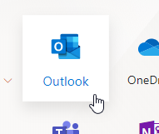
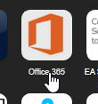
Accessing your School Email
- Open the internet and login to MySchool
- Click on Office365
- Select Outlook
- Select New Message


CC (and BCC)
When sending an email, you may see under the To section there is CC, and sometimes even BCC. These are very useful when sending emails to multiple people. You can enter email addresses into the sections and they will do different things.
Entering an email into the CC section, or carbon copy section, will mean this person will receive a copy of the email, but isn’t the addressee (it’s a bit like FYI/for your information, but this person shouldn’t have to respond to the email as it’s not addressed to them. The recipient can see who has been copied into this message.
The BCC section, or blind carbon copy section, works in a similar way but with a slight alteration. The recipient cannot see who has been bcc’d. This has a few uses in the workplace where you don’t want the recipient to see who has received a copy of the email.
For example, a newsletter sent to 1000 people should never release your email address, so companies often enter your email in the BCC section so you get a copy of the newsletter, but your not the direct recipient. It’s similar to sending a snapchat to ‘public’ whilst you send the snap to a friend (the recipient).

Replying and forwarding an email
Once you receive an email, you will also be able to reply to the message. When you reply to an email it means you are sending an email back, or responding, to the person who originally sent it to you. Because the message is going back to the person who sent it to you, the email address is automatically entered. RE appears in front of the subject to tell you it’s a reply.
We can also forward an email, which is a bit like sending on an email to someone else. This is where you receive an email from one person, and instead of sending a message back, you send the message onto someone else. FW in the subject tells you it has been forwarded.

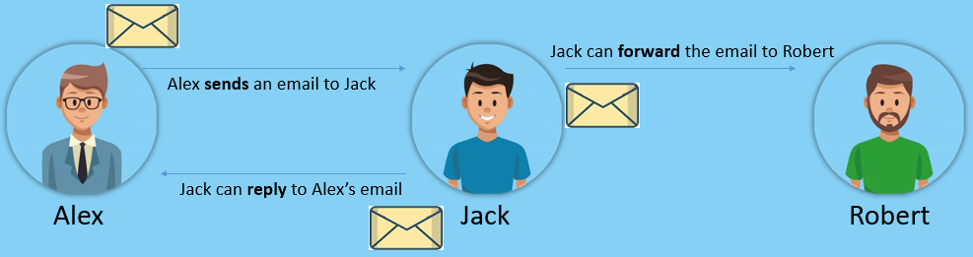


Attaching Files and Images to Folders
We can also receive an email with an attachment from someone. When we receive an email which has an attachment, the paperclip icon appears next to the message. You can then open the email and also open or save the attachment!

The Internet and the World Wide Web
The Internet is a massive global network of computers linked together. It is physical hardware that is connected together.
The World Wide Web or WWW is the collection of millions of websites that sits on within the Internet. We access the WWW through a web browser like Google Chrome, Firefox or Internet Explorer. It is the software on the internet.


Search Engines
Search Engines like Google use complex Algorithms to do three tasks:
- Crawling – where websites are discovered;
- Indexing - where a website is analysed and stored in huge database;
- Retrieval – You receive a list of relevant web pages on the topic you are searching for.
When we use a search engine such as Google or Bing, their web crawler creates a list of search results. These contain a list of relevant webpages, with the most relevant at the top.


Virus’
A virus is computer program designed to deliberately damage or make a computer system unreliable by slowing down the processor.
They have been created to cause damage to your computer, including:
- Corrupting files and folders
- Deleting Data
- Stealing your personal information
- Infecting your computer so it slows down/stops working
To combat computer virus’, you should not open email attachments from people you do not know. We can also install anti virus software on your computer and make sure you keep it up-to-date. One major way to stopping a computer virus getting onto your computer is ensuring you do not download files from the internet unless it is from a known safe site and you have permission from a parent or guardian.
We can also scan USB memory sticks for viruses.

